Jawad Alikhel Juan Carlos, and Hannah Clayton

Dr. Abina Primo

COSC2311_1 Java 1

1 December 2020

“Scribe” Application User Manuel

Our application, Scribe, is a text editor application that simultaneously gives the user the opportunity to submit due dates and view how much time they still have to complete that assignment.

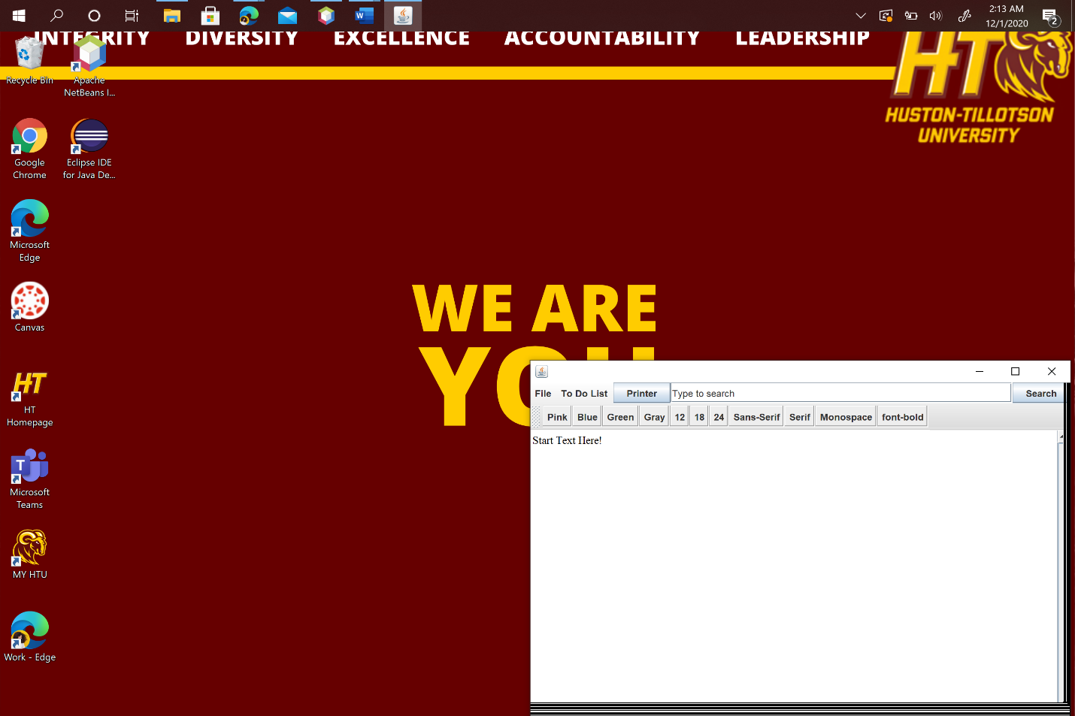

Upon first opening our application, here is the screen you will see first. In the Menu Bar, the user is provided several options including a File tab letting users save and open files, a To-Do list tab, a Print button so that the user can print their documents, a search bar to view online resources, and several text formatting options for your text. Let’s walk through all of these functions and how they work!

1. File Open

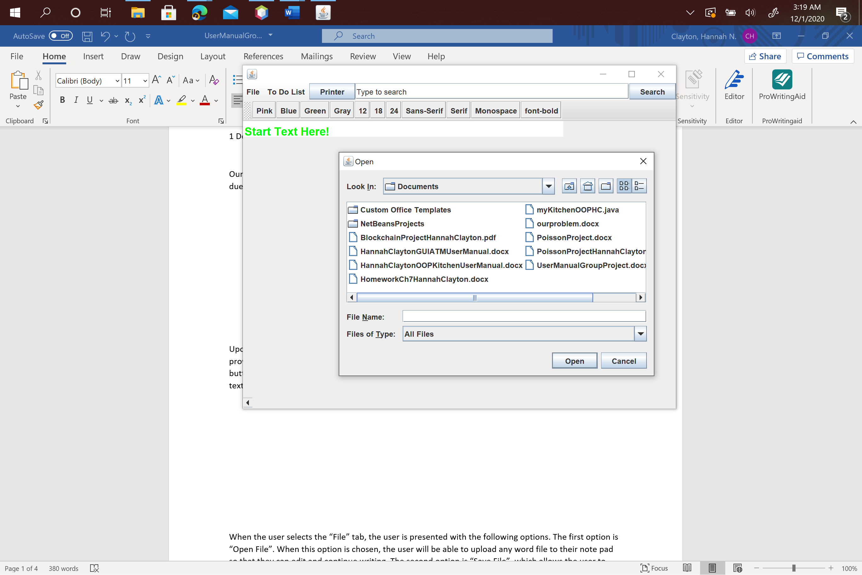

When the user selects the “File” tab, the user is presented with the following options. The first option is “Open File”. When this option is chosen, the user will be able to upload any word file to their note pad so that they can edit and continue writing.

1. File Save

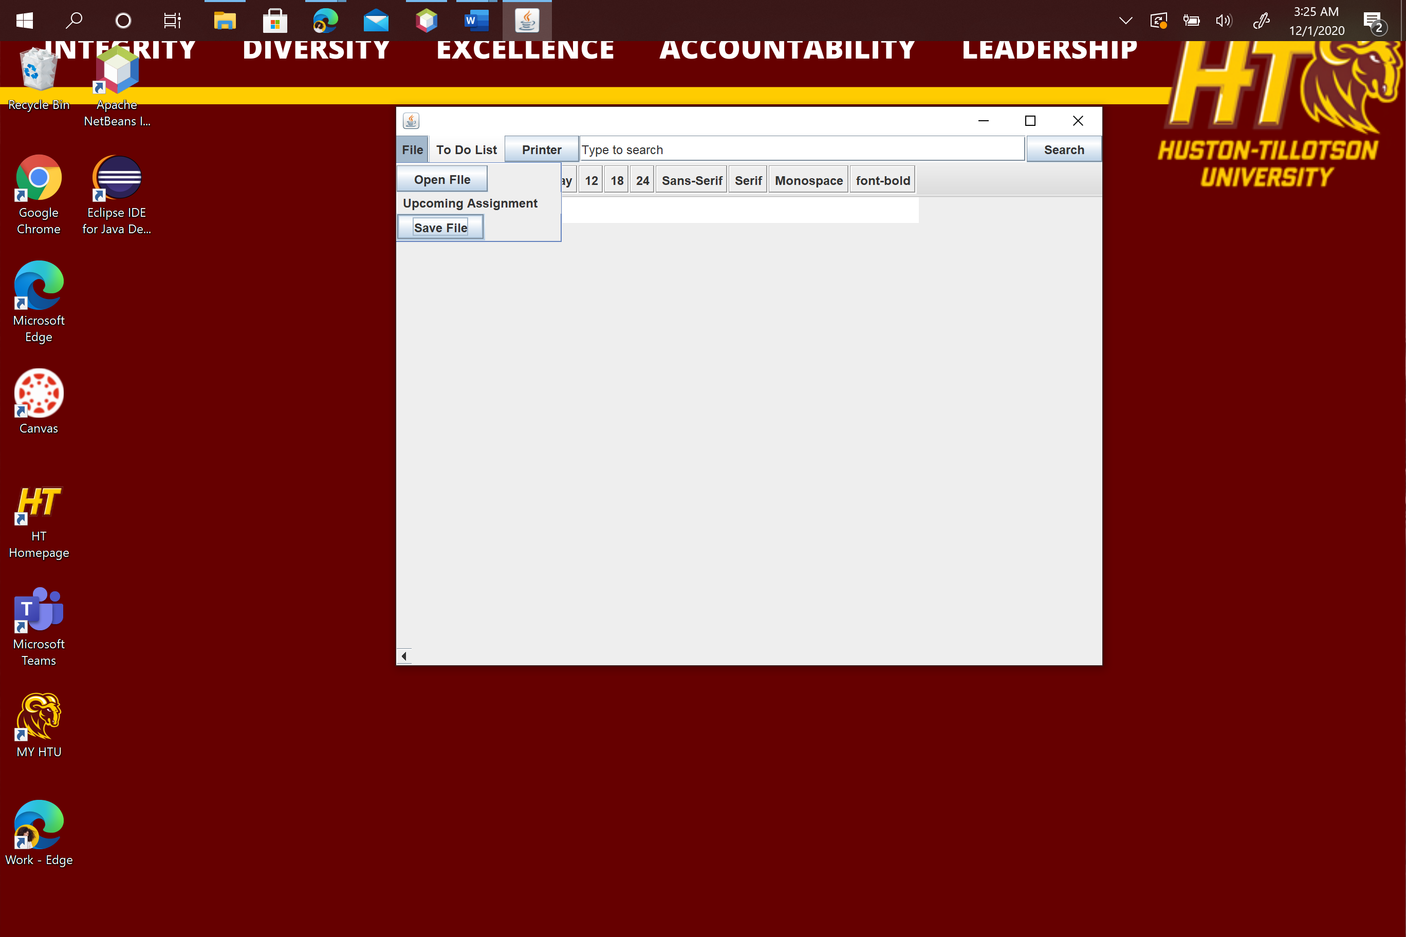

The second option is “Save File”, which allows the user to save their progress to their files.

1. To-Do List

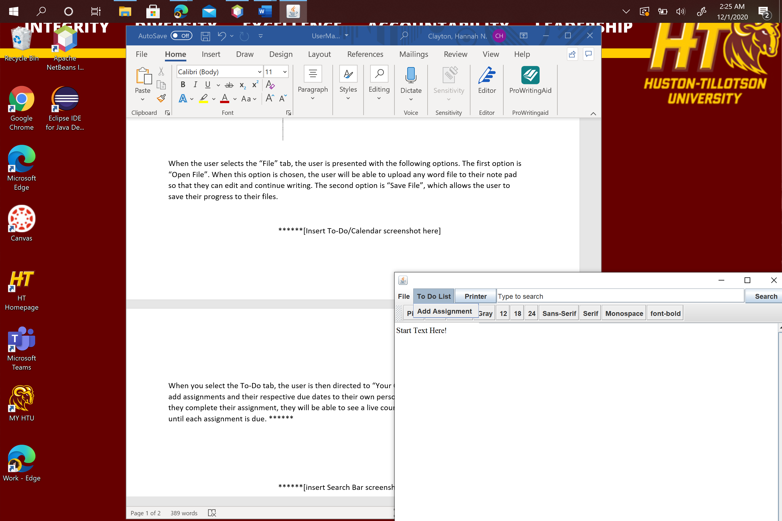

When you select the To-Do tab, the user is then directed to “Your Calendar”. In this tab, the user can add assignments and their respective due dates to their own personalized calendar! Upon doing so, as they complete their assignment, they will be able to see a live countdown of how much longer they have until each assignment is due. This feature is still buggy and is currently in the works.

1. Search Bar

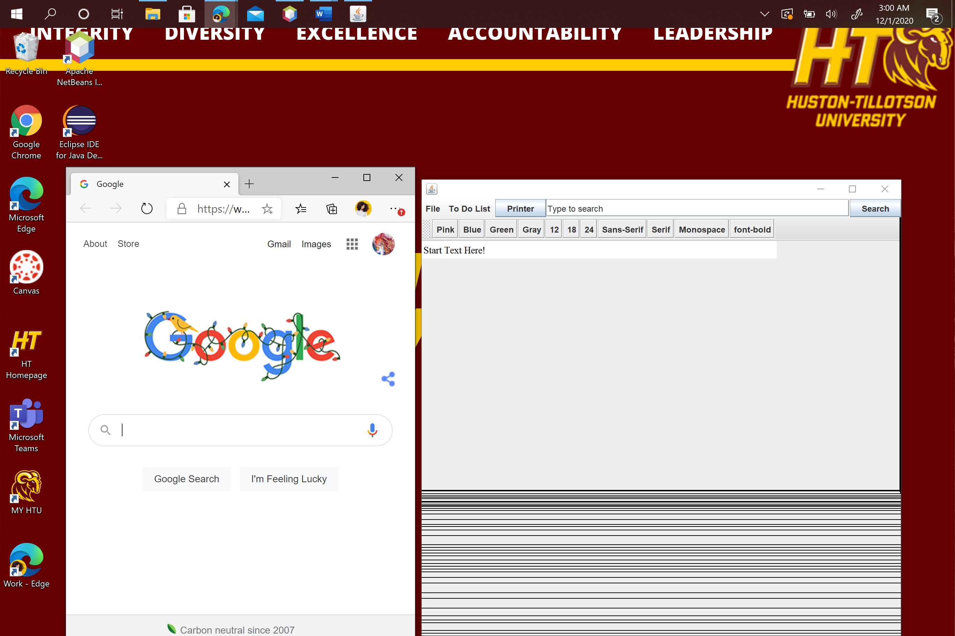

With the “Search” function, the user has the capability to search for online resources to aid them in their writing as they are writing.

1. Print

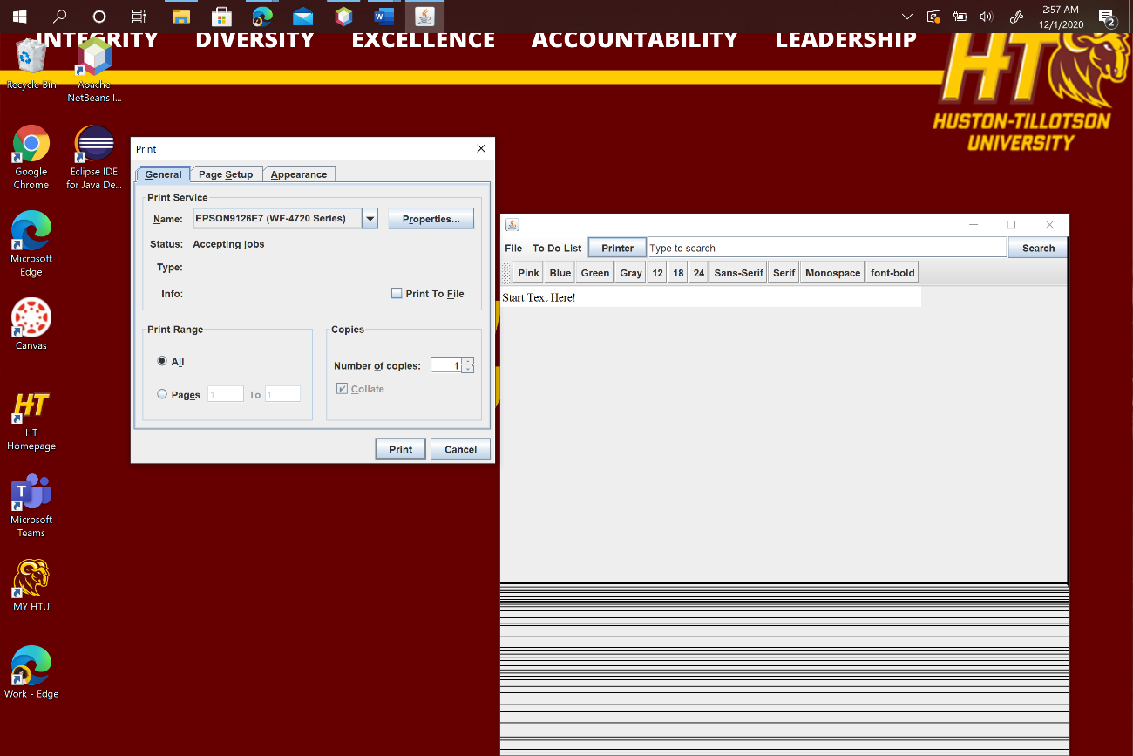

The Print button, when pressed, triggers a pop-up window giving the user their local printer options so that they can print their work that they have completed.

1. Formatting

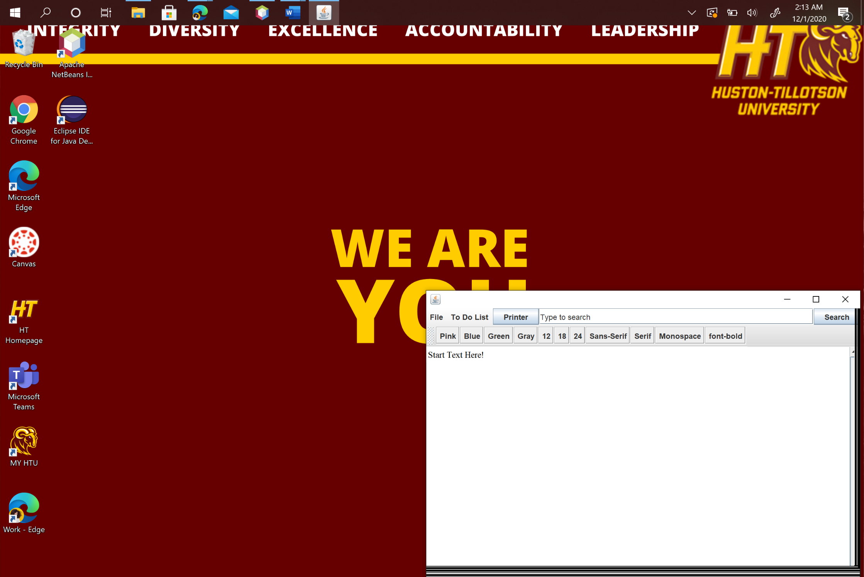

When looking at this row, there are several text editing options to make the users writing unique and fun! There are four different color options:

1. Colors:

Pink-

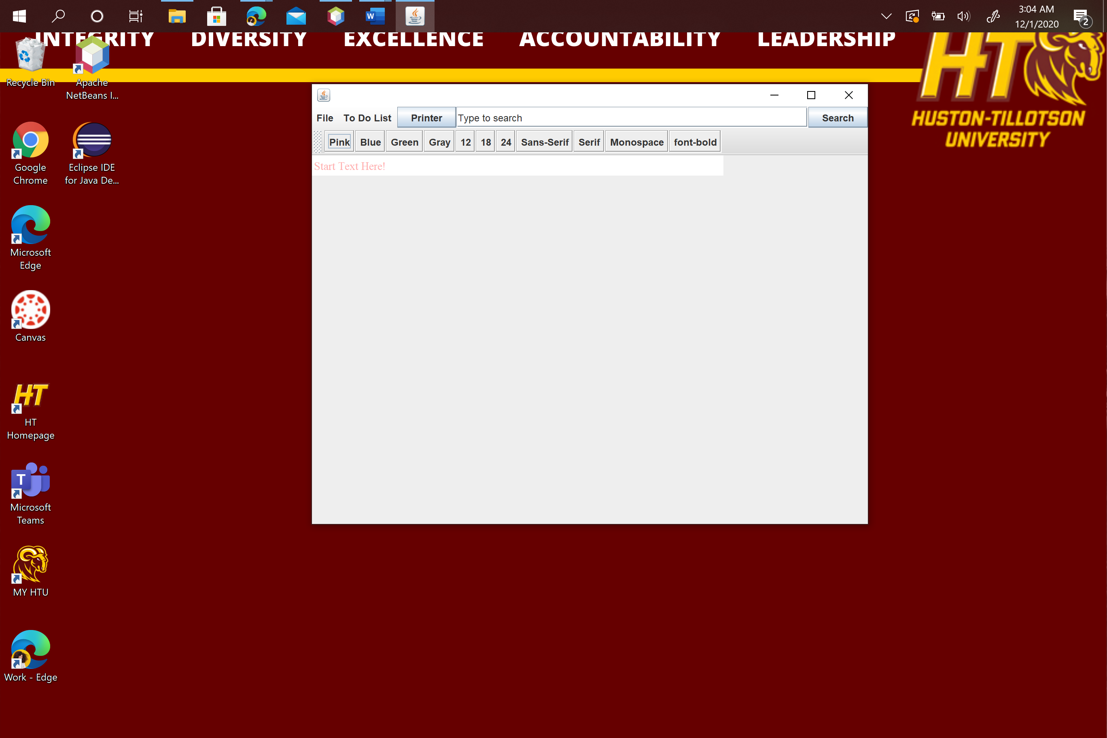

Blue-

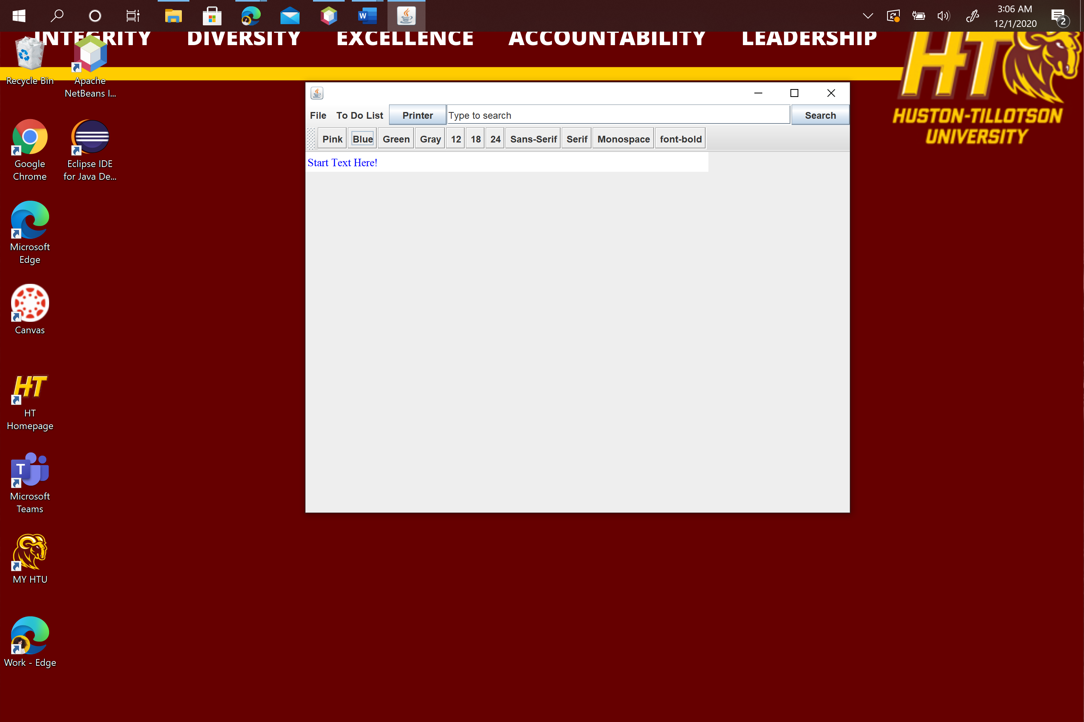

Green-

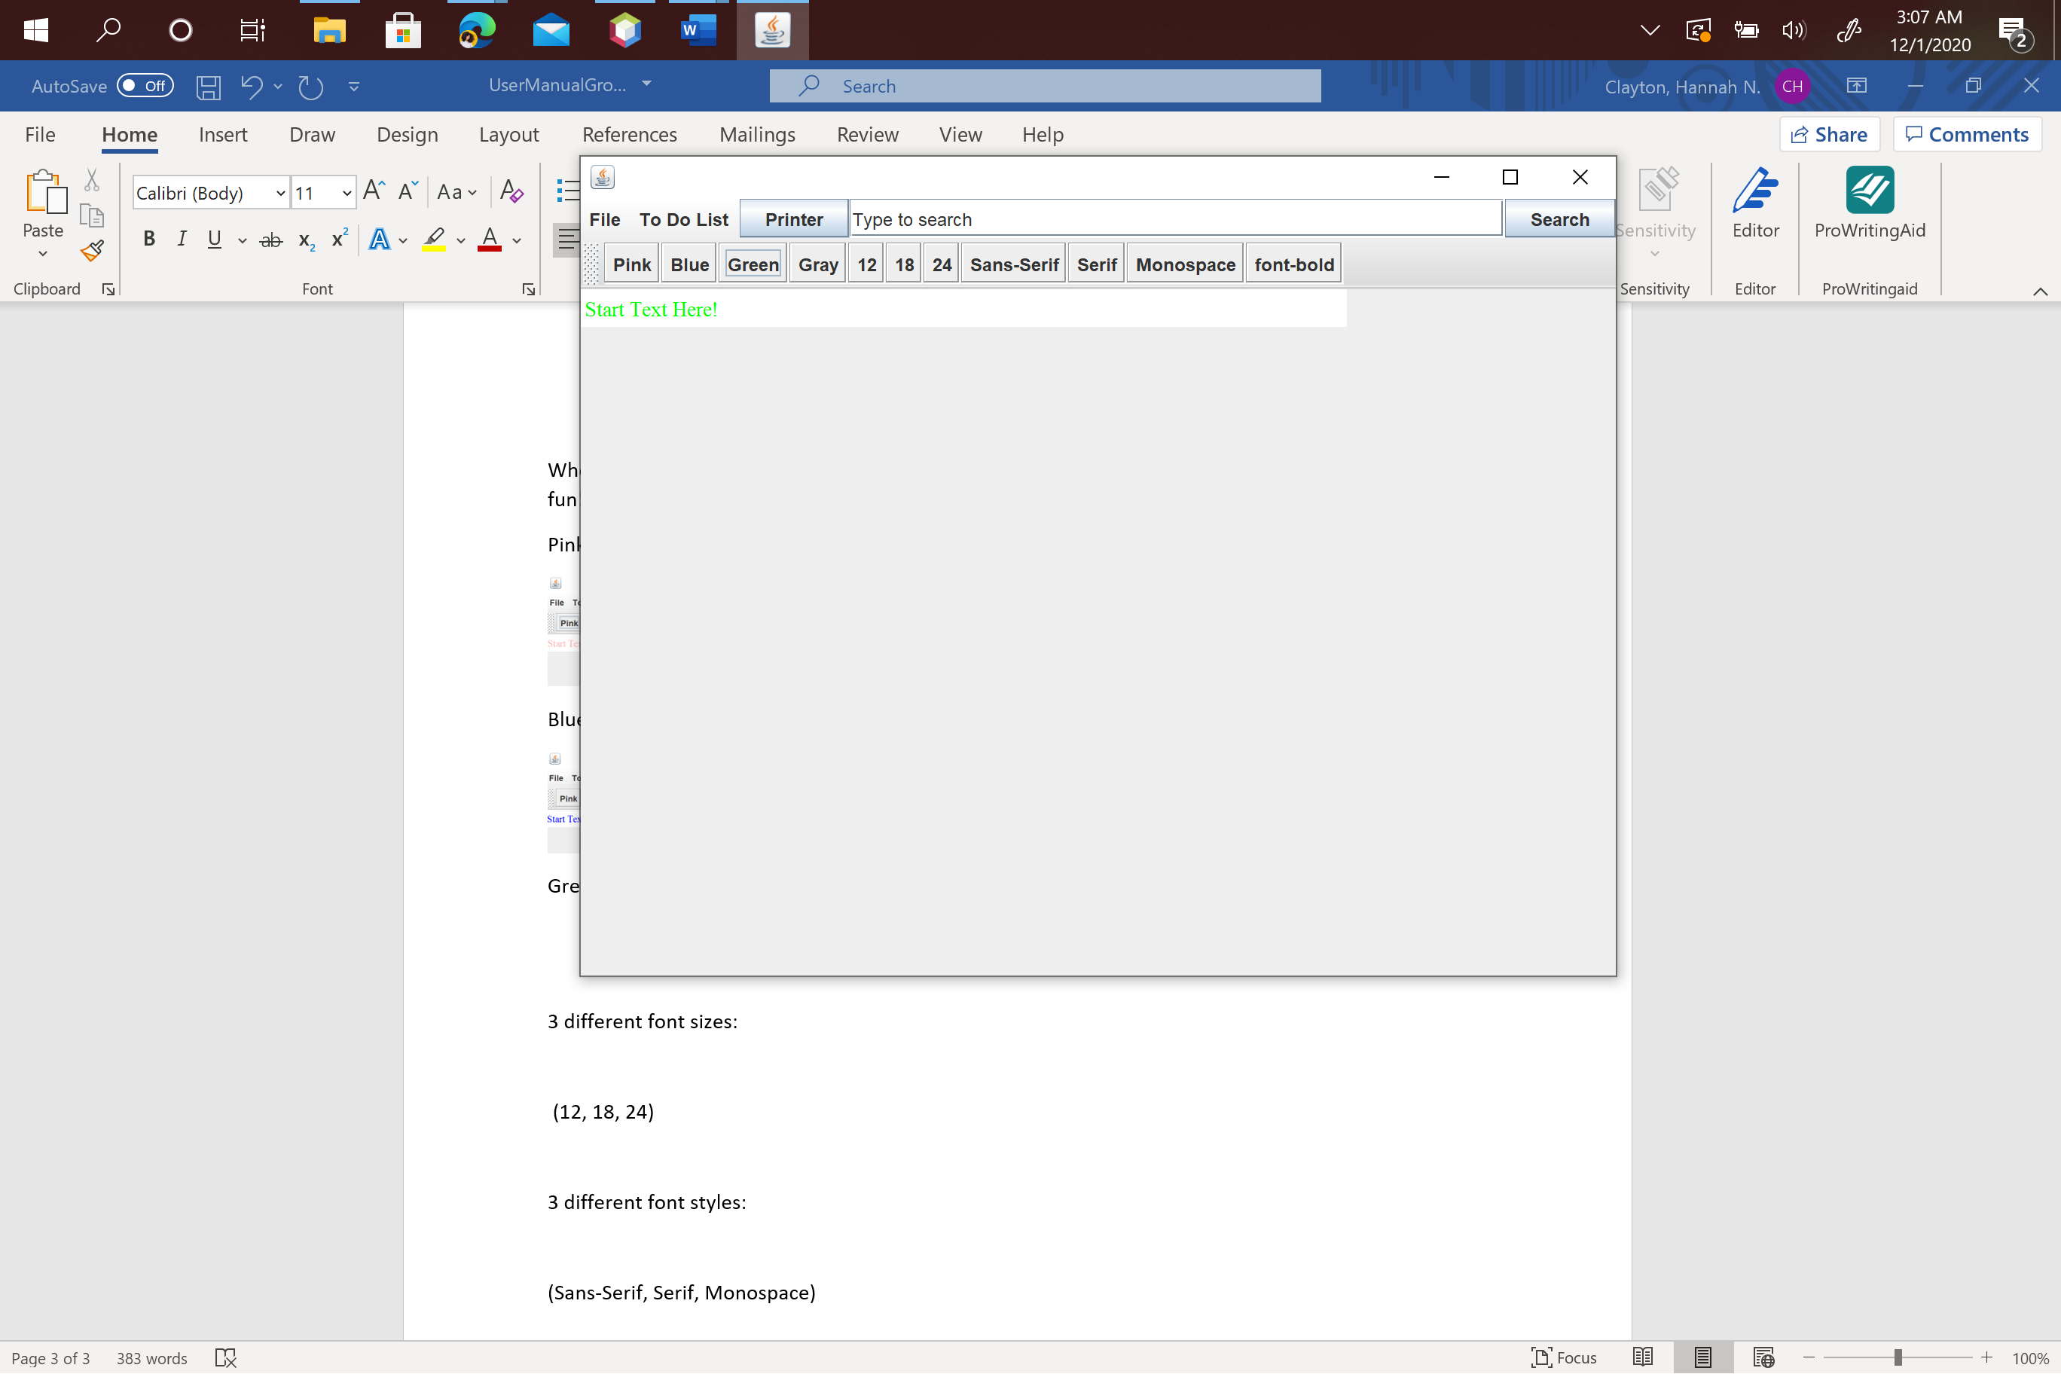

Gray-

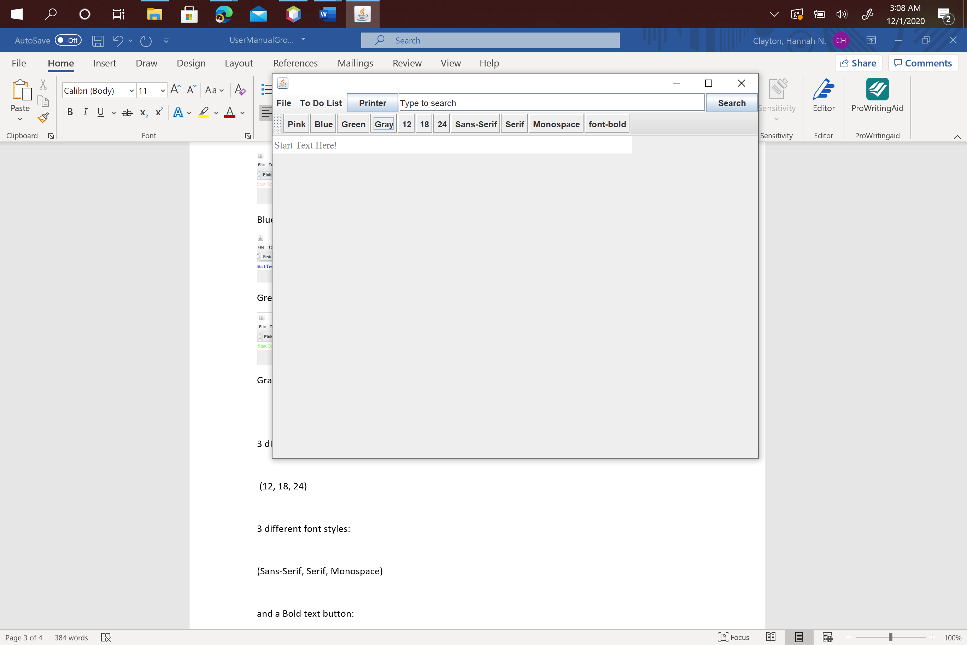

1. Font Sizes

3 different font sizes:

12:

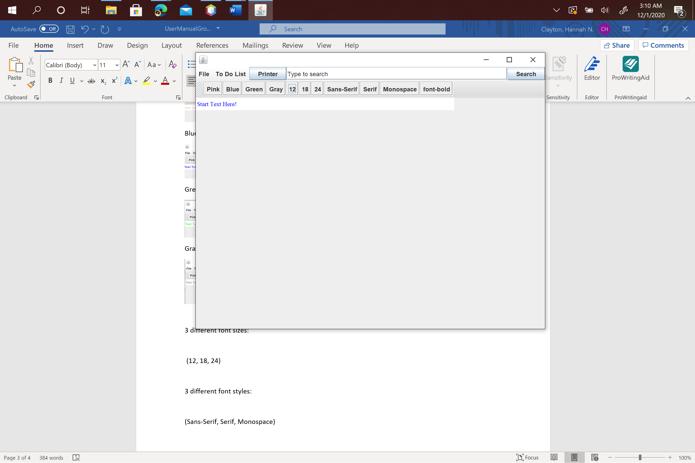

18:

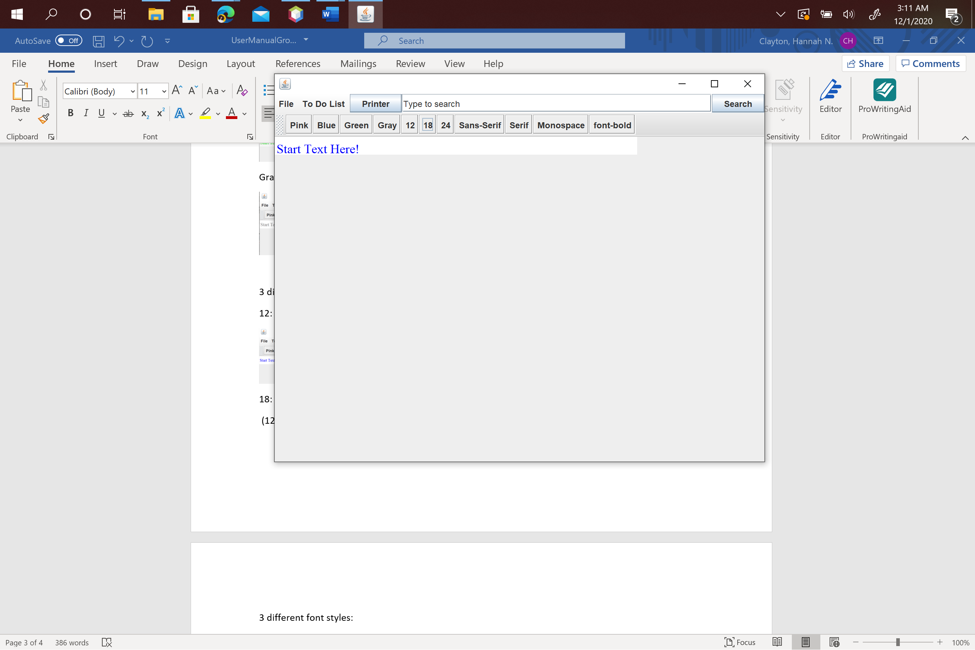

24:

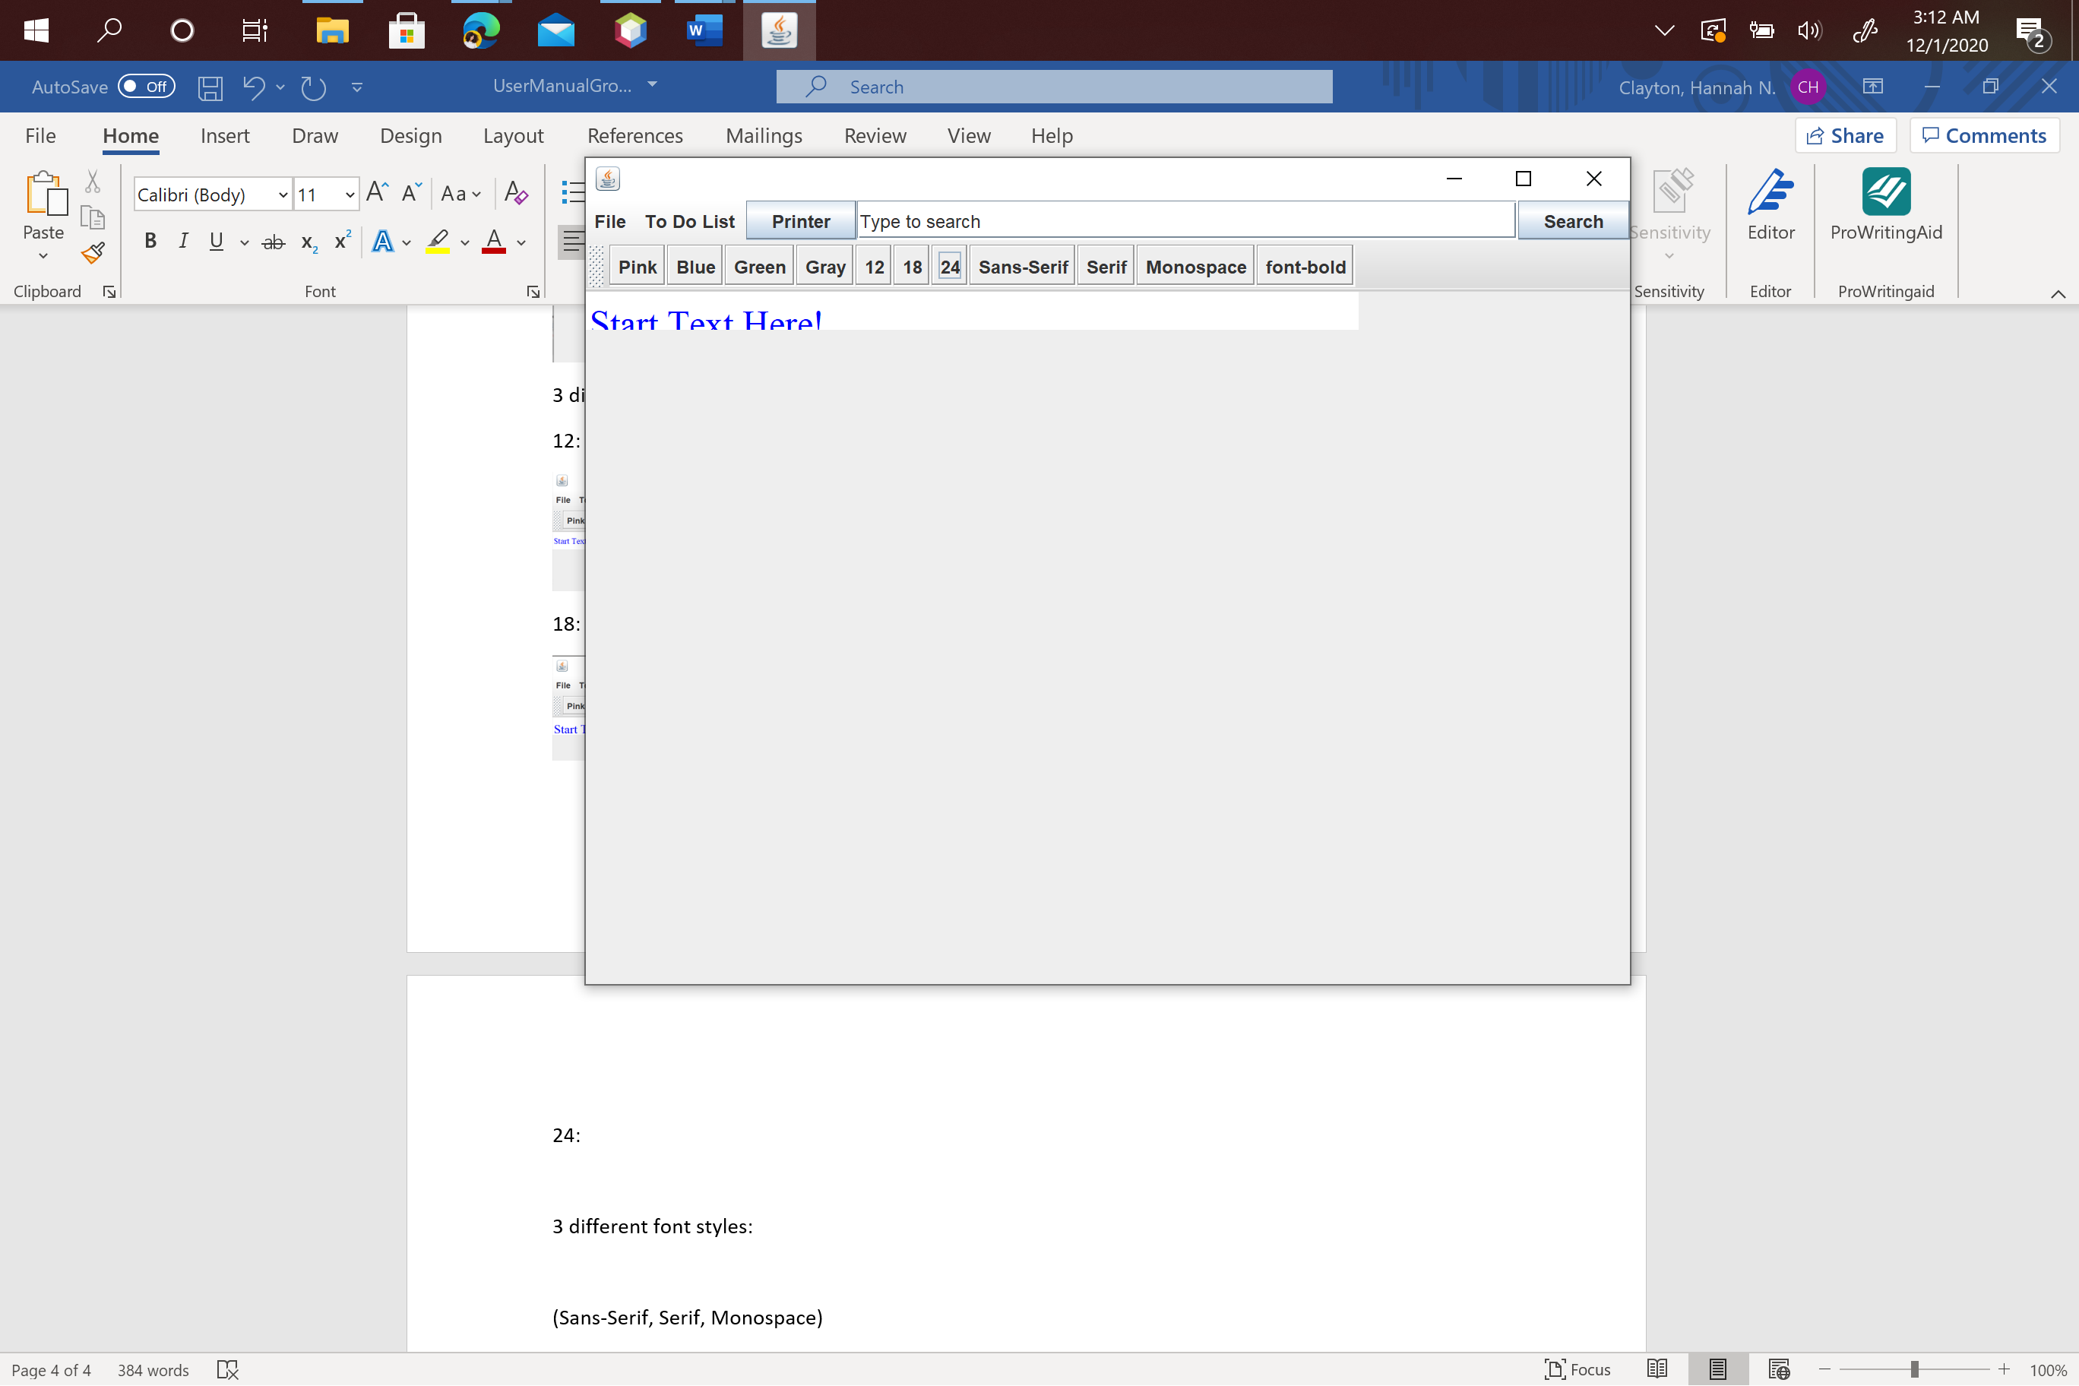

1. Font Styles

3 different font styles:

Sans-Serif:

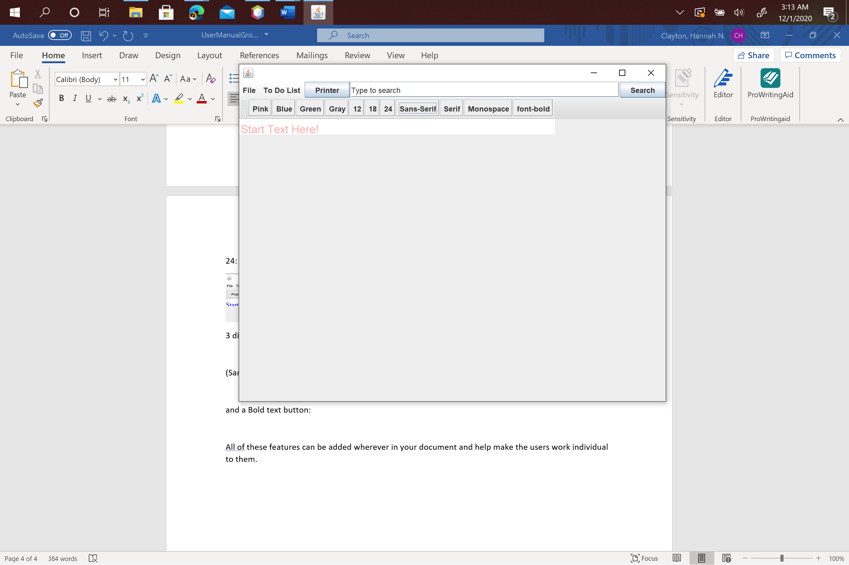

Serif:

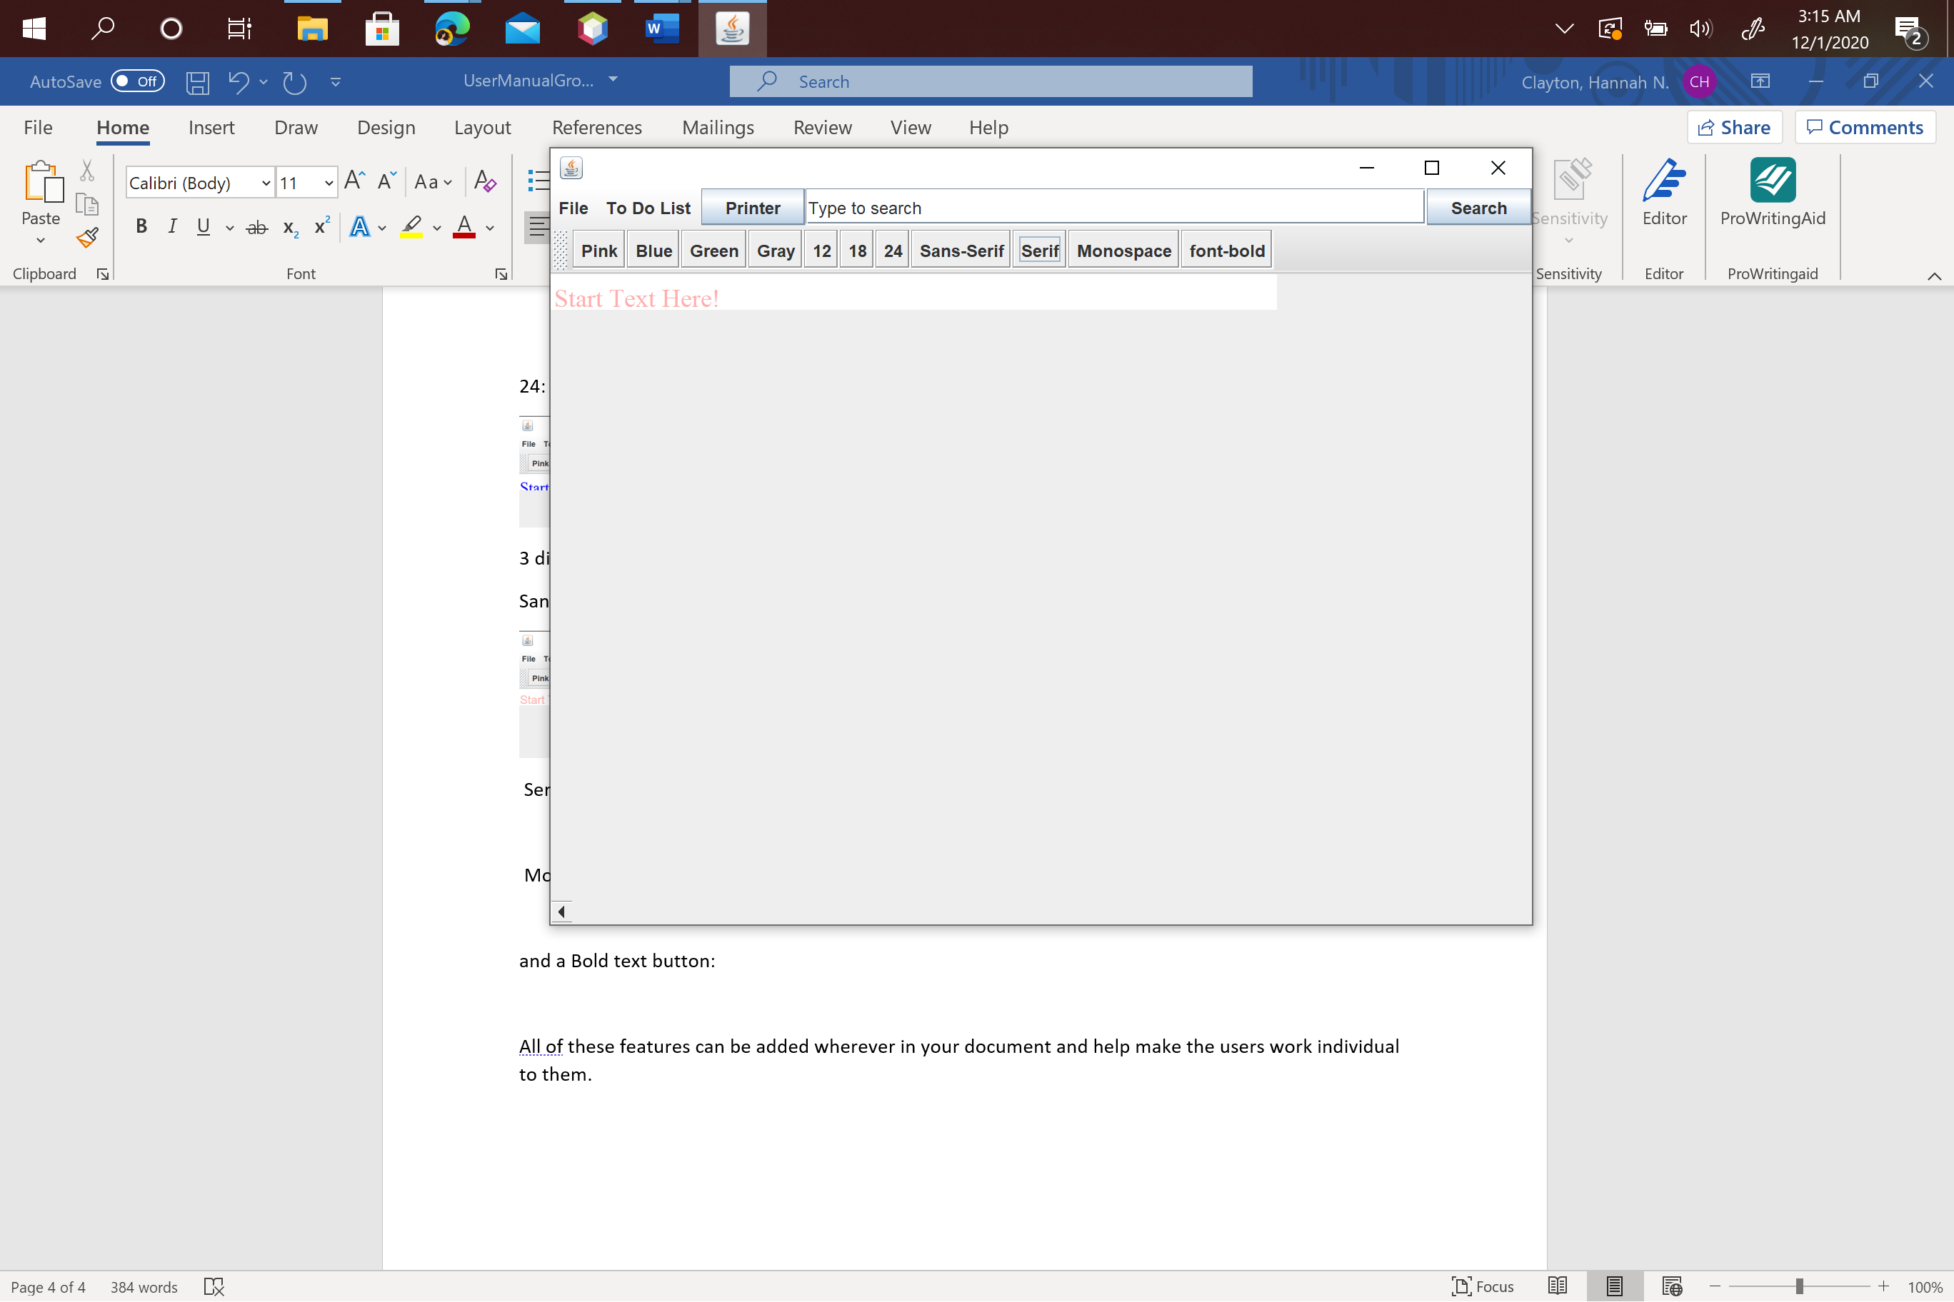

Monospace:

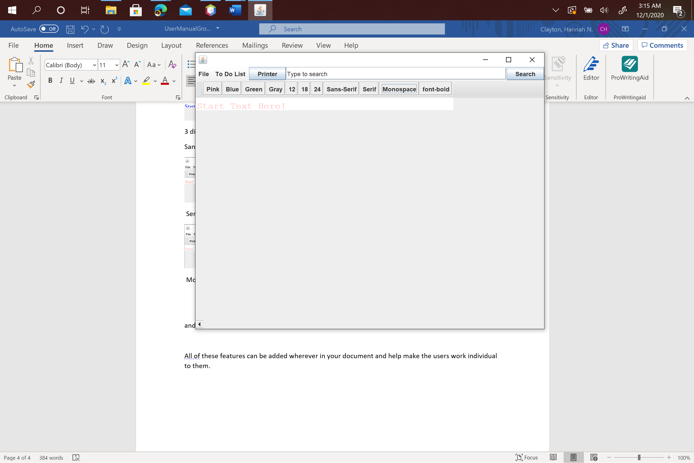

1. Bold

and a Bold text button:

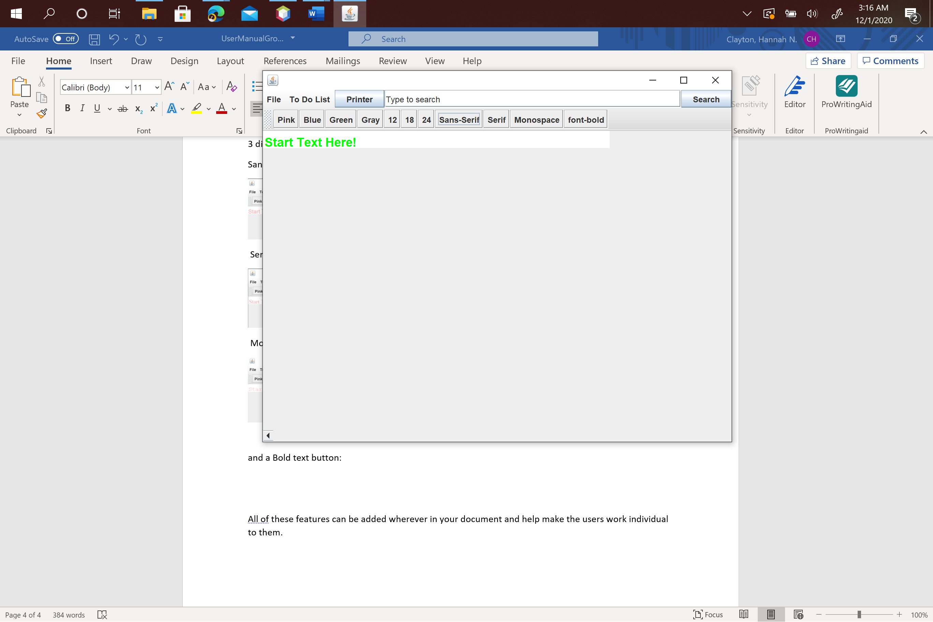

All of these features can be added wherever in your document and help make the users work individual to them.